Automated Tuning Runbook
By Henok Teka

How to check if feature is enabled
Run on Primary server

SELECT name, actual_state_desc, reason_desc
FROM <yourDatabase>.sys.database_automatic_tuning_options;
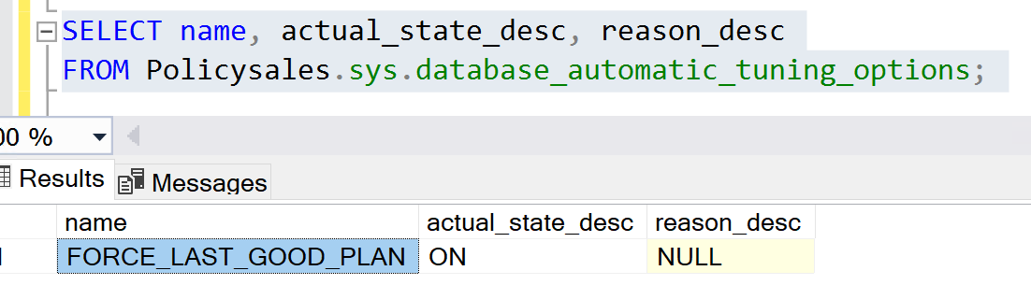

If you run on Secondary, you will get wrong result.
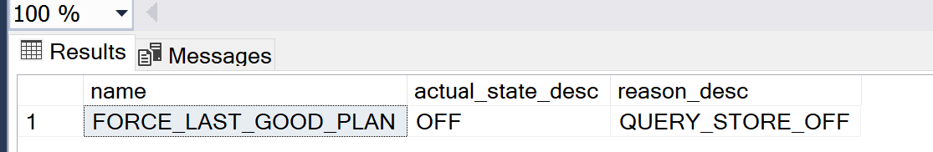

After failover and replica becomes a Primary one, feature will be automatically enabled on new Primary and disabled on old Primary replica.

How to Enable feature
- Make sure that Query Store is enabled in database and in Read-Write mode
- Run command only on Primary replica
ALTER DATABASE <yourDatabase>
SET AUTOMATIC_TUNING ( FORCE_LAST_GOOD_PLAN = ON );

- You will get an error if you try to enable the feature on Secondary replica.
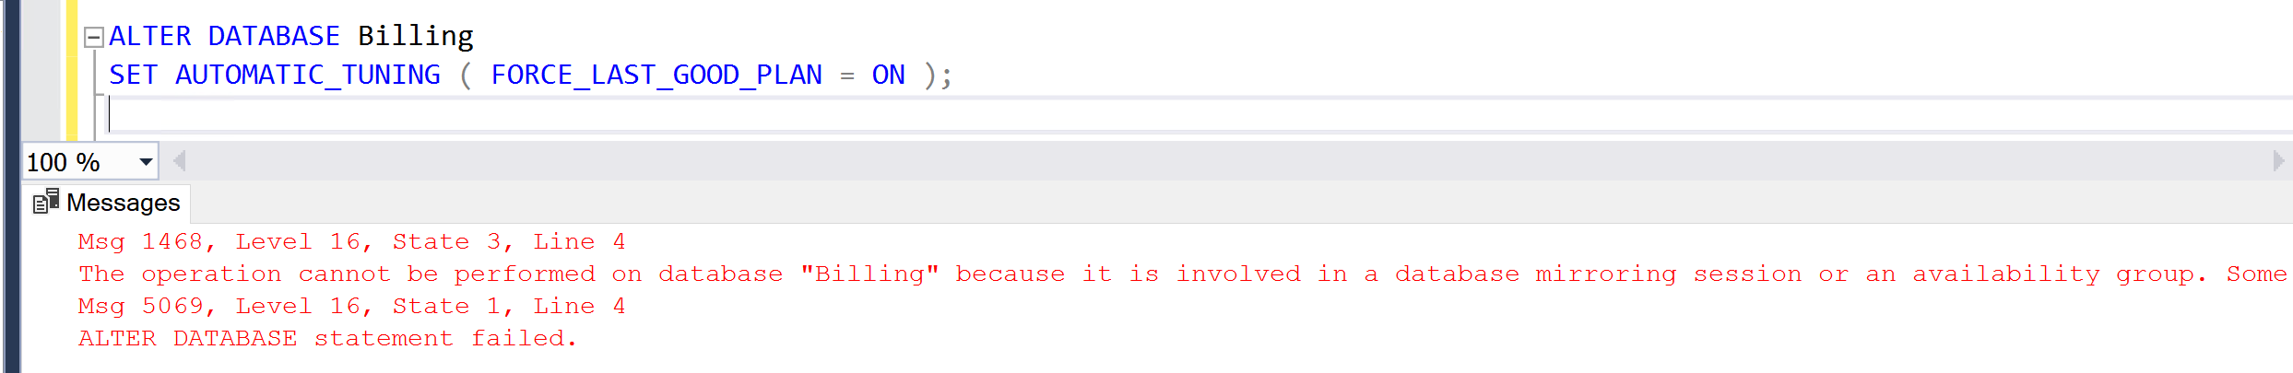

How to check recommendations
Note, after failover existing recommendations are cleared, and system starts gathering data from the beginning.

Execute query (assuming PolicySales is your target database)
SELECT
name,reason,valid_since,last_refresh,state,is_executable_action,is_revertable_action, score, details
from Policysales.sys.dm_db_tuning_recommendations order by last_refresh desc
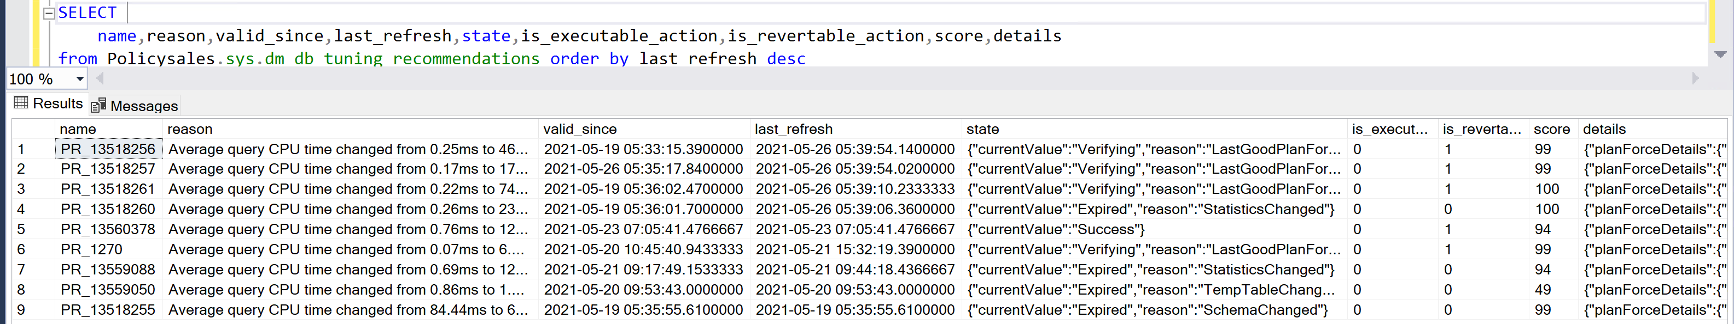

To see currently forced plans by the feature, add condition
SELECT
name,reason,valid_since,last_refresh,state,is_executable_action,is_revertable_action, score, details
from Policysales.sys.dm_db_tuning_recommendations
WHERE is_revertable_action = 1
AND execute_action_initiated_by = 'SYSTEM'
order by last_refresh desc
You may also verify this information by checking Queries with Forced Plans tab in Query Store.
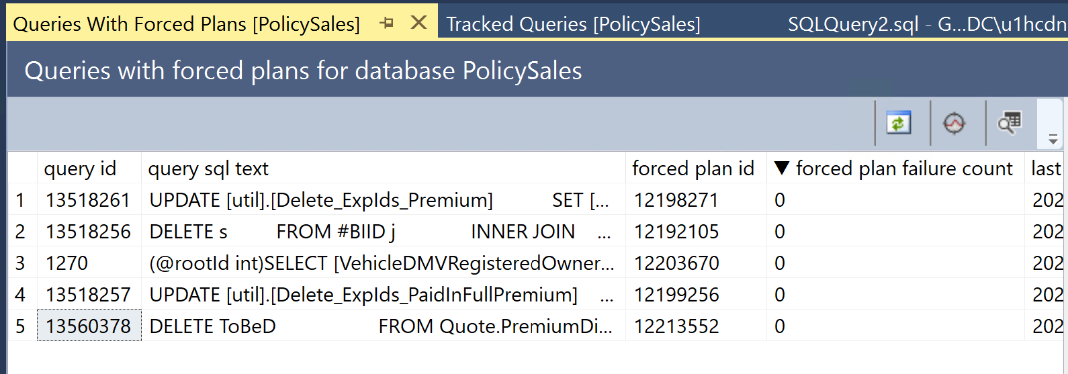

How to check quality of recommendations (plan forcing)

You may get query_id from result of query above (and remove prefix PR_), then open tab Tracked Queries in Query Store, then enter required query_id. Forced plan is checked. You can visually see the benefits of the forced plan.
Sometimes you need to expand time interval in Configure tab to see results of executed queries.
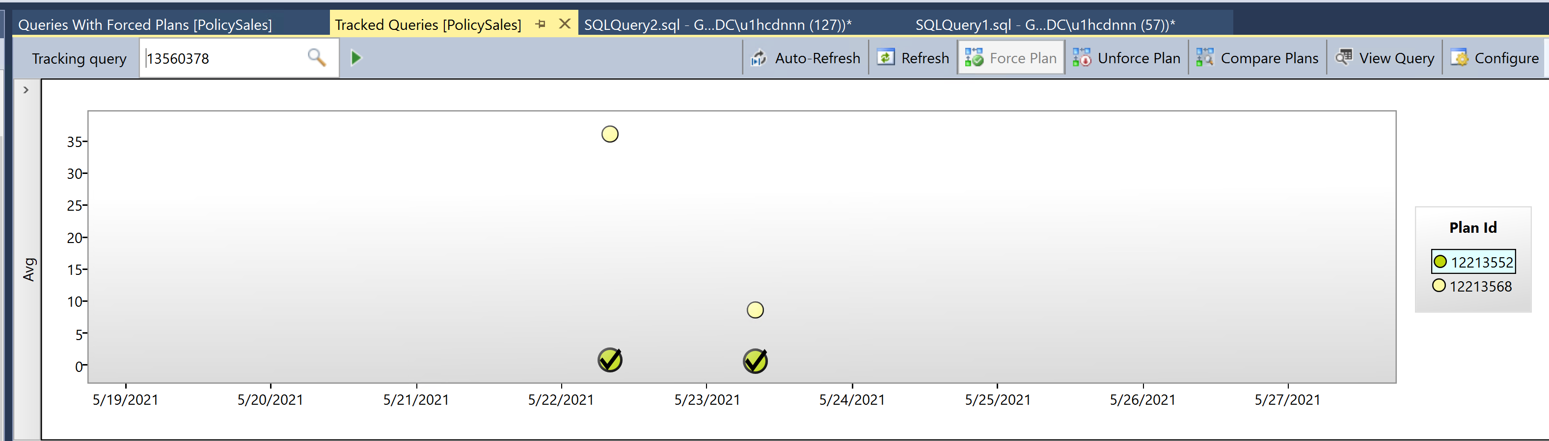

How to get details of feature recommendations
Execute query
USE PolicySales
GO
SELECT TOP 10 reason, score,
script = JSON_VALUE(details, '$.implementationDetails.script'),
planForceDetails.*,
estimated_gain = (regressedPlanExecutionCount + recommendedPlanExecutionCount)
* (regressedPlanCpuTimeAverage - recommendedPlanCpuTimeAverage)/1000000,
error_prone = IIF(regressedPlanErrorCount > recommendedPlanErrorCount, 'YES','NO')
FROM sys.dm_db_tuning_recommendations
CROSS APPLY OPENJSON (Details, '$.planForceDetails')
WITH ( [query_id] int '$.queryId',
regressedPlanId int '$.regressedPlanId',
recommendedPlanId int '$.recommendedPlanId',
regressedPlanErrorCount int,
recommendedPlanErrorCount int,
regressedPlanExecutionCount int,
regressedPlanCpuTimeAverage float,
recommendedPlanExecutionCount int,
recommendedPlanCpuTimeAverage float
) AS planForceDetails
ORDER BY score desc;

Results will be similar to below screen where you can see estimated gain in seconds based on number of executions of recommended plan vs regressed one.
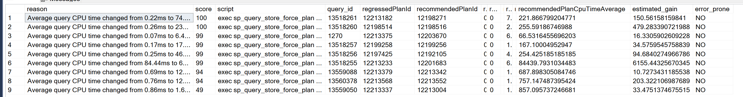

How to undo feature recommendations
To undo plan forcing, simply unforce the plan.
You can use Queries with Forced Plan tab and simple click on Unforce Plan button with chosen plan highlighted.
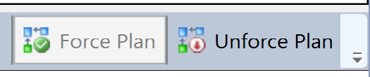
Another way to unforce the plan is to execute stored procedure
EXEC sp_query_store_unforce_plan @query_id = 13560378, @plan_id = 12213552;
Here values for query_id and plan_id are taken from screenshot above.
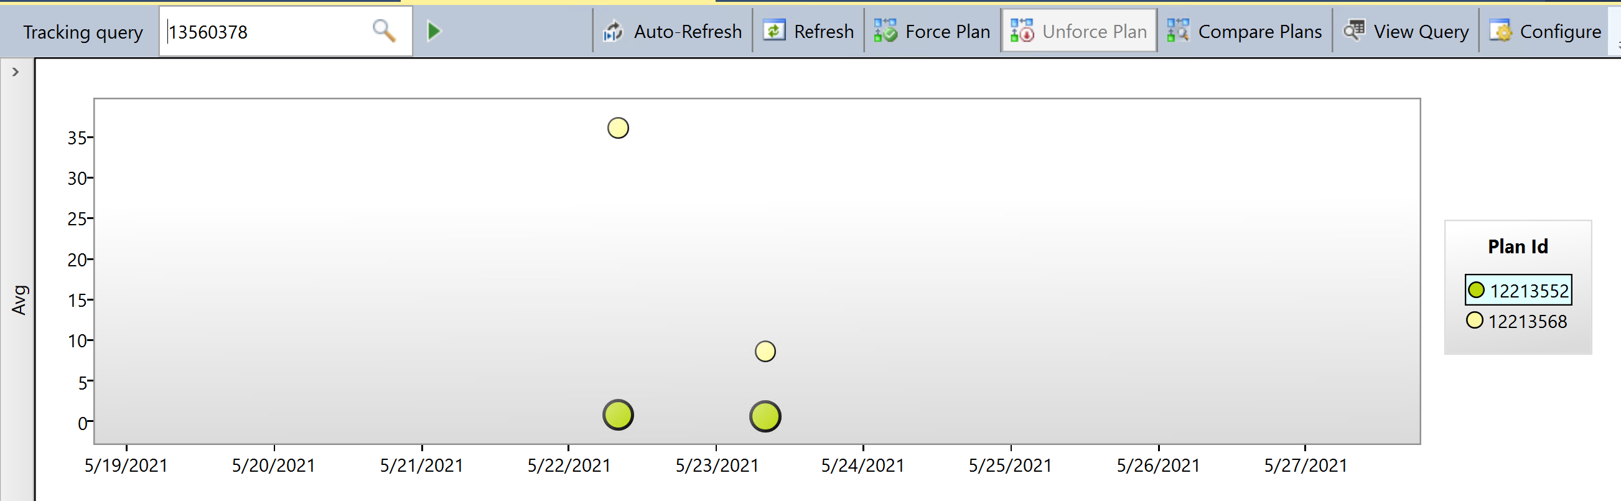
And re-executing the same SQL statement, you can see the values in state and is_revertable_action has changed:
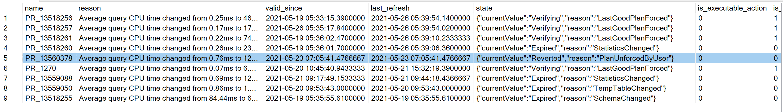

Preventing Plan from Re-Forcing
You may delete plan from query store after un-forcing it and prevent it for consideration for further recommendations by the feature in the future (if plan is still valid).
For example, to delete unforced earlier plan 12213552, execute command
EXEC sp_query_store_remove_plan @plan_id = 12213552
After that in Tracked Queries tab of Query Store for the same query_id, we will see only remaining plans, and Automatic Tuning will not be able to use deleted plan in the further analysis (until new executions will generate similar plan, but with another plan_id)
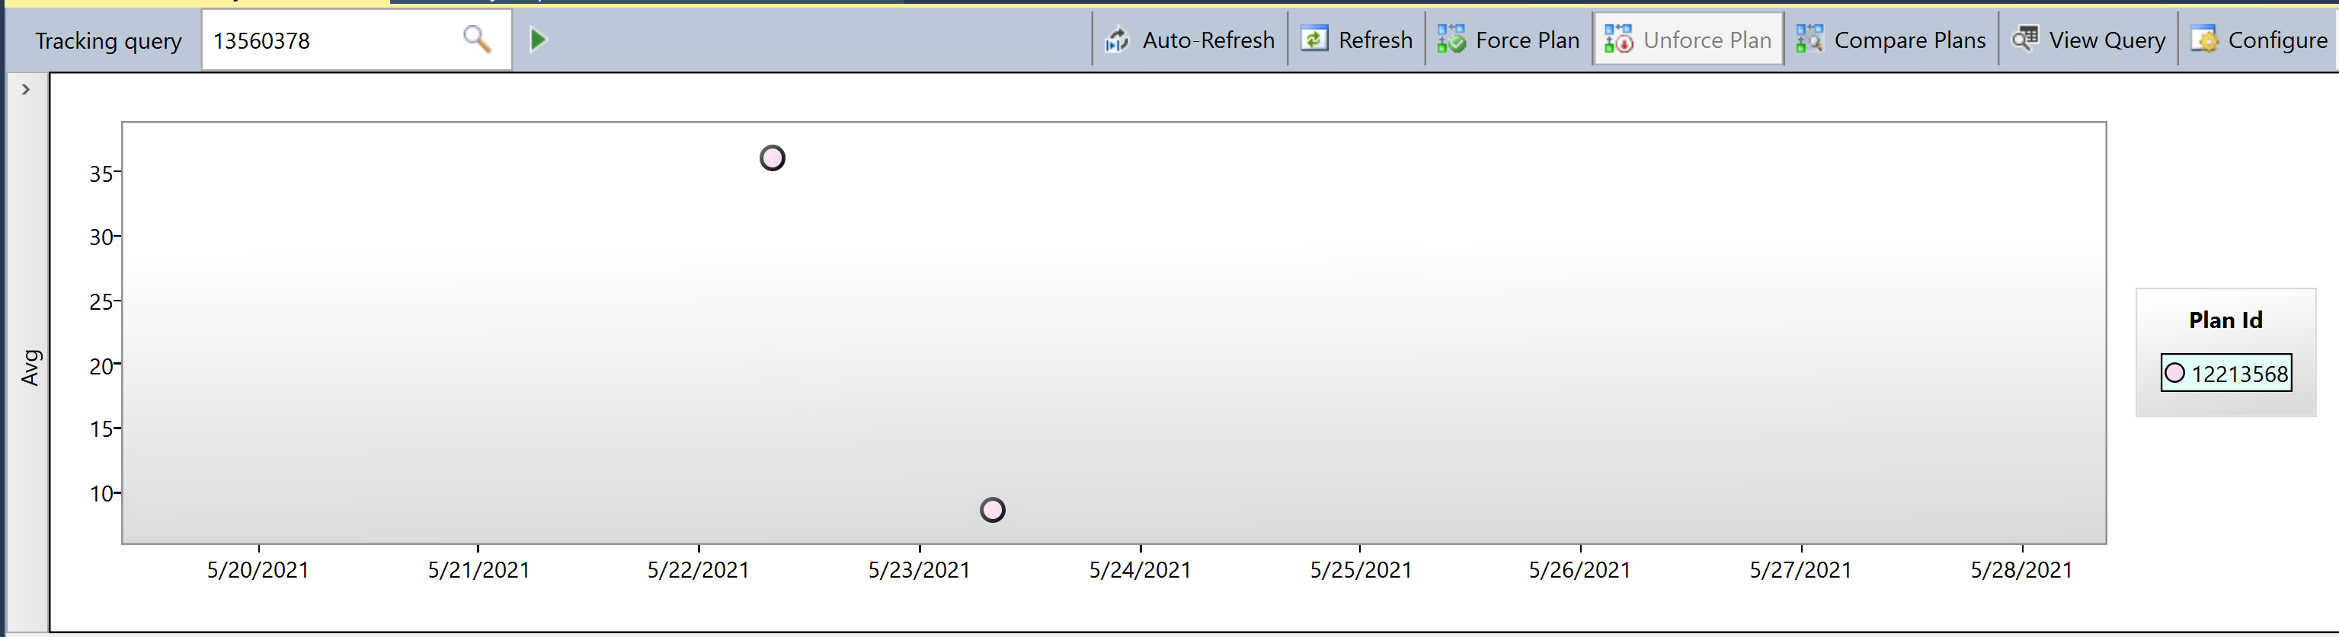

How to Disable feature
- Make sure that Query Store is enabled in database and in Read-Write mode
- Run command only on Primary replica
ALTER DATABASE <yourDatabase>
SET AUTOMATIC_TUNING ( FORCE_LAST_GOOD_PLAN = OFF );
